**StudyBuddy**

StudyBuddy is a social accountability app that keeps you motivated by sharing photos of your study session.

## Team GOATs

[Ethan Morin](mailto:ethan.morin1@maine.edu)

[Noah Rushing](mailto:noah.rushing@maine.edu)

[Alex Ayer](mailto:alexander.ayer@maine.edu)

[Denis Kevine Simost Sima Matha](mailto:denis.simost@maine.edu)

[Sany Dagher](mailto:sany.dagher@maine.edu)

[Xander Drolet](mailto:alexander.drolet@maine.edu)

# **Problem**

Studying is usually an isolated task. Without outside motivation, learners may struggle with procrastination and burnout.

For example, it is easy to fall into a trap of doing something other than studying when you should be studying. However, when you receive a text or something similar from somebody who is actively working, you’ll feel inspired to get your work done as well.

Prior solutions which are actively used are people hanging out with each other while they study. That said, people aren’t always available to meet with each other in person.

How can we allow people to encourage each other to study through shared productivity while not needing to be physically available to each other in a manner that is social, scalable, and asynchronous.

We aim to solve this problem by creating a fun, interactive, asynchronous application that allows people to share when they are studying, encouraging their friends to join them and get some work done too.

# **Prior Solutions**

## Focusmate

Focusmate is a virtual coworking platform where users schedule a session with a random partner to keep them accountable. At the scheduled time, both users join a video call and state their study goals, then silently work alongside each other.

Unlike Focusmate, which relies on scheduled, synchronous sessions, StudyBuddy is an asynchronous platform where friends can share their study sessions at any time. StudyBuddy’s social-media like approach creates a more engaging and community-driven environment

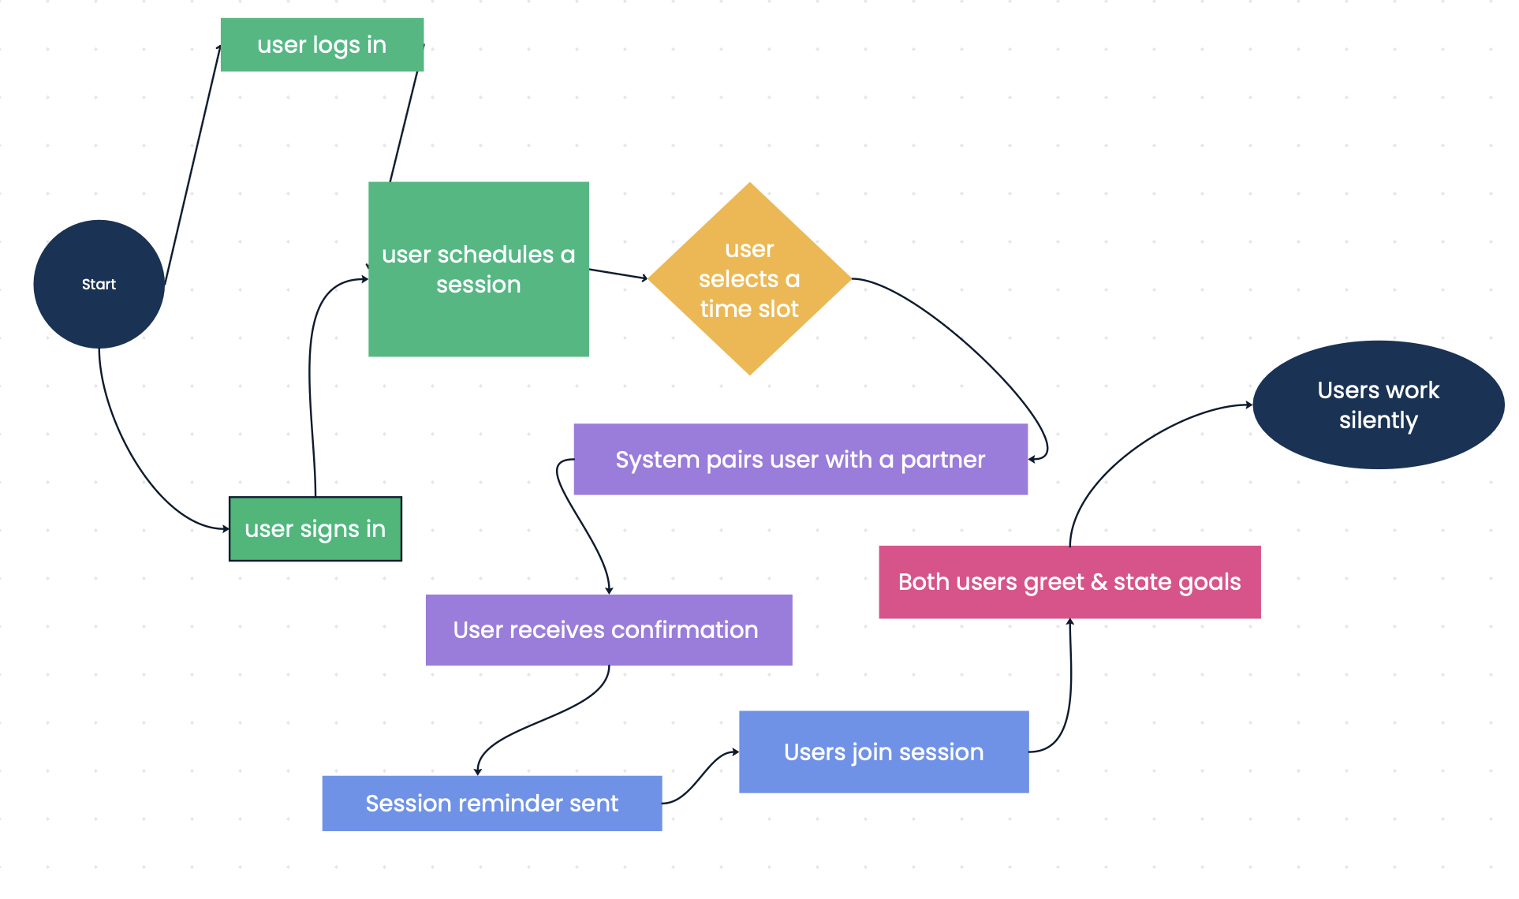

## Pomodoro Timer Apps

Pomodoro timer apps work to help individuals develop healthier studying habits, in some cases even allowing users to gamify their experience by providing “progress” on a goal by staying focused.

While pomodoro apps focus on encouraging individual studying habits, StudyBuddy takes the opposite approach by encouraging people to share their studying habits with others. When users can see when their friends are studying instead of just tracking their time, people will be motivated through peer accountability and shared experiences.

[**Task Flow Diagram**](https://lucid.app/lucidchart/af4862fa-2d6f-4937-a809-ab754a1ab779/edit?viewport_loc=-1201%2C-936%2C2772%2C1520%2C0_0&invitationId=inv_c106d055-5634-4735-90cb-9a07c20ed559)

## Discord Study Communities

Some students join Discord servers that are intended to serve as study groups where they are able to join voice calls, share progress, and encourage each other in real-time. This creates a similar sense of shared accountability to what StudyBuddy aims to do.

Discord study groups still require users to be online at the same time, making participation dependent on availability. StudyBudy alleviates this by allowing users to share their study moments asynchronously in a manner that notifies their friends to check it out later, providing motivation and accountability when they see their friends' shared images without needing to be in a live call or chat.

[**Task Flow Diagram**](https://lucid.app/lucidchart/9375bbb3-8c1e-4302-b3e9-59988e0299db/edit?viewport_loc=-194%2C-458%2C3363%2C1946%2C0eqBfotfVGlV&invitationId=inv_0f4cc848-246c-4520-8a9f-5bba6af9fa4e)

# **StudyBuddy**

StudyBuddy is a mobile application designed to enhance study accountability and motivation through social engagement. Inspired by BeReal, StudyBuddy allows users to share real-time photos of their study sessions with friends. The app promotes consistency with features like study streaks, friend notifications, and reminders to maintain momentum. By fostering a community-driven approach to studying, StudyBuddy helps users stay focused, motivated, and connected with their academic goals.

**Real-Time Study Photo Sharing** – Users receive daily prompts to take and share a live study photo with their friends, creating a social and accountable study environment.

**Friend Activity Notifications** – Users get notified when their friends post, encouraging them to study at the same time and build mutual motivation.

**Study Streaks** – The app tracks how many consecutive days a user studies and posts, rewarding long streaks with visual badges and potential in-app achievements.

**Streak Reminders** – If a user hasn’t posted within a set timeframe, they receive a friendly reminder to keep their study streak going.

**Study Stats & Progress Tracking** – Users can view their study history, longest streak, and overall engagement trends to monitor their habits.

### **How StudyBuddy Stands Out**

**Encouraging Authentic Study Habits**Unlike traditional study tracking apps, which focus solely on timers and stats, StudyBuddy integrates a social aspect that encourages real, accountable study habits. Users are motivated to study not just for themselves, but to engage with and support their friends.

**Real-Time Interaction for a More Engaging Experience**Most study tracking apps are solitary. StudyBuddy makes studying more interactive by notifying users when their friends are active, creating an immediate incentive to join in and stay productive.

[**Task Flow Diagram**](https://lucid.app/lucidchart/d1817eb3-405b-4bca-9180-fa44347c7dee/edit?viewport_loc=-717%2C-1224%2C8464%2C3297%2C0eqBfotfVGlV&invitationId=inv_83d2c2fb-2ae0-45d8-8690-ccc2c037feb5)